All parents/carers may apply for the non-local enrolment of their child. A separate application form is required.

To be eligible for a non-local placement one or more of the following criteria must be addressed.
Criteria (Not in any order of priority)
• Siblings already enrolled at the school and the impact on family
• Medical reasons
• Safety and supervision of the student before and after school
• Compassionate circumstances
• Structure and organisation of the school

A written application on the out of area application form must be completed addressing the criteria.
When addressing the criteria it should be clear and concise and specifically prove the case for enrolment of the student to the placement panel.

Appropriate documentation relating to the criteria should be included as the placement panel will base their decision on this information. Applications are often rejected based on insufficient documentation and an inappropriate case.

• Oral or other submissions will not be accepted.

• Applications containing false or misleading information will be rejected.

The number of students a school may enrol is limited by the availability of classroom space. This means that some schools may not have room left for non-local enrolments after accommodating local children.

To avoid disappointment parents should check that there are places available in a school before applying.

The flowchart on the following page highlights the procedure for assessing an out of area application form.
The out of area application placement panels are held as required. The placement panel will consist of one executive staff member, one teaching staff member and one school community member.

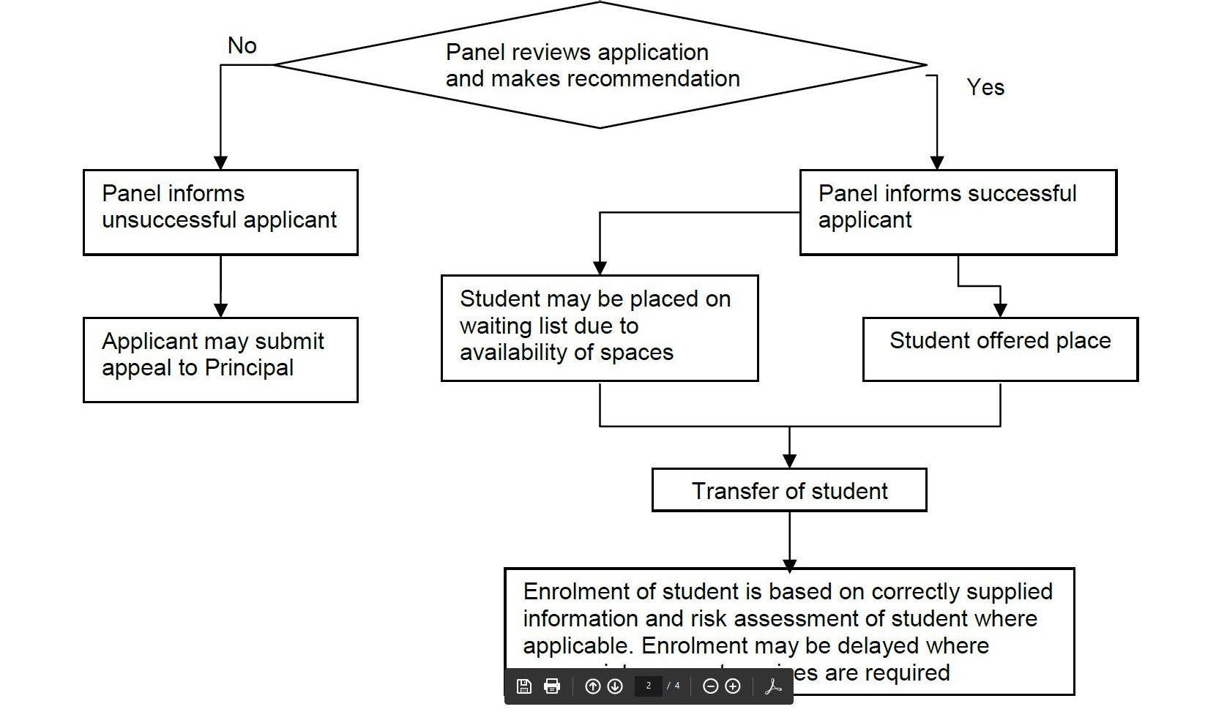

Appendix 1

