Tuesday 20/07/21 - Term 3 Week 2

Subject | Activity | Resources/Links
Morning Routine | - Sing ‘The Days of the Week’ song, then answer these questions: How many days are in a week? How many days are school days? Which days are school days? What do we call the other two days? (the weekend). Which two days are the weekend? What happens on the weekend?  What day is it today? What was yesterday? What will tomorrow be?  - Sing ‘The Months of the Year’ song, then answer these questions: What month is it? What was last month? What will next month be? What month is your birthday?  - Talk about what the weather looks like and feels like - talk about what clothes should be worn to suit the weather  - Sing the phonics song | - https://www.youtube.com/watch?v=mXMofxtDPUQ  - https://www.youtube.com/watch?v=5enDRrWyXaw  - https://www.youtube.com/watch?v=jPVbJ-IaHIw
Reading | - Read a book to someone at home using the ‘Half-Pint Kids’ website AND/OR  - Have someone read a book to you – Can you retell what happened in the beginning, middle and end of the story? Can you talk about the setting and characters? | - https://halfpintkids.com/online-materials/
Sight Words | - Choose a fun activity to practise reading and/or writing your sight words
 | Fruit Break
Phonics | - Sing the ‘Digraphs’ song by Jack Hartman on YouTube  - Watch the ‘sh’ video  - Optional: Can you put 1 or more of the words from the video into a sentence? | - https://www.youtube.com/watch?v=NK8_Tvu6bJk  - https://youtu.be/g3-1cCBF3jk
Writing | - Using a piece of paper and coloured pencils, independently use detailed pictures and words to tell your audience a story (refer to the ‘Writing Instructions’ document regarding how to support your child when writing)  - Stimulus question: Imagine you are building your own robot. What will it look like? What jobs will it do for you? What adventures will you and your robot have? | - View attachment for stimulus visual

 | Break
Mathematics | Choose 1-3 of the following activities each day:  (Please note, larger numbers may be used when your child is ready)  - Count forwards to 30. Once you have mastered this, try counting forwards from any given number (e.g. start counting from 7, start counting from 12 etc.)  - Count backwards from 20. Once you have mastered this, try counting backwards from any given number in the range 20-0 (e.g. count backwards from 18, count backwards from 11 etc.)  - Name the number that comes before and after a given number (e.g. “what comes before the number 7? What comes after the number 7?”)  - Print the number flashcards (or use paper to make your own). Put the flashcards in a random order. Say each number as quickly as you can  - Practise writing the numbers 0-20 on a whiteboard or piece of paper  - Choose a number from 4-10. How many ways can you show this number? Think of tally marks, dice patterns, dominoes, tens frames. What numbers go together to make the number? (e.g. 2 and 4 make 6, 3 and 3 make 6, 5 and 1 make 6 etc.)  - Practise adding numbers together using objects, your fingers, and/or counting on. Can you record the sums on a whiteboard or piece of paper (e.g. ‘5 and 2 is 7’ or 5+2=7)
 | Break
Other | - Can you find 5 ‘always’ (healthy) foods and 5 ‘sometimes’ (unhealthy) foods. Draw and label what you find.

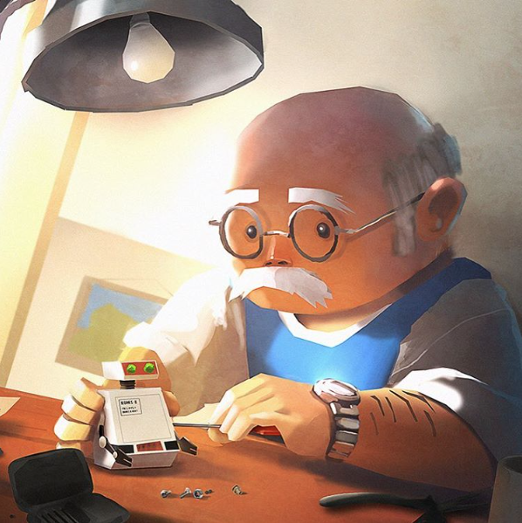

Reading Sight Words
Make a sight word car park. Read the word before parking your car  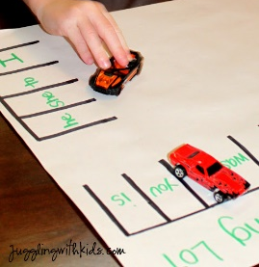 | 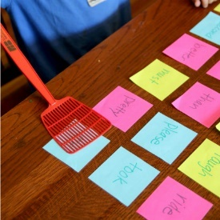  Slap the sight words with a fly swatter when each word is called | Sight word dominoes | 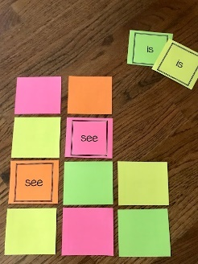  Play a game of ‘memory’ | Play sight word hopscotch  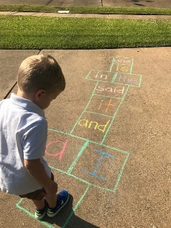
Hide sight words around the house  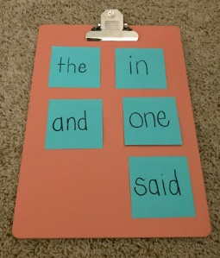 | 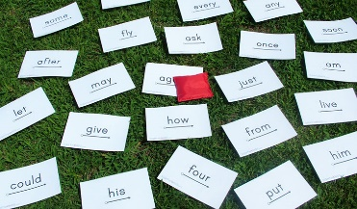  Sight word beanbag toss. What word did your beanbag land on? | Sight word bingo | 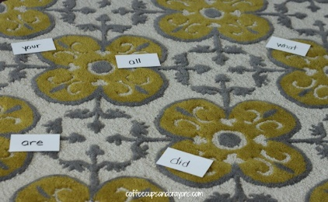  Sight word stomp. Stomp on the word when it is called | Read the flashcards as quickly as you can  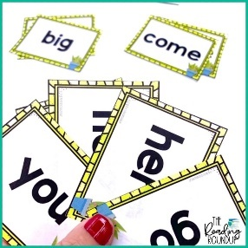
Writing/Making Sight Words
Make your sight words out of playdoh  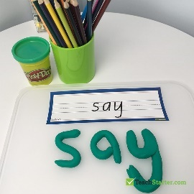 | 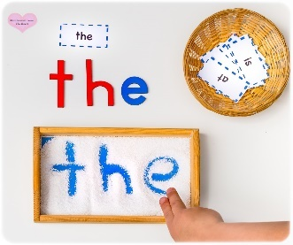  Put flour/rice/sand in a tray and use your finger to write your sight words | Use a ‘dry-erase’ marker and write your sight words on the table or window  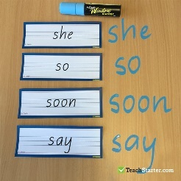 | 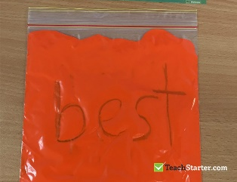  Put some paint in a zip lock bag and use a cotton bud or your finger to write your sight words | 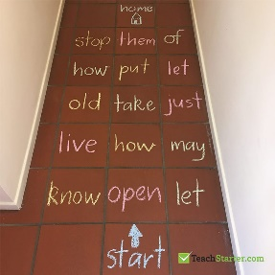  Write your sight words on the concrete using chalk
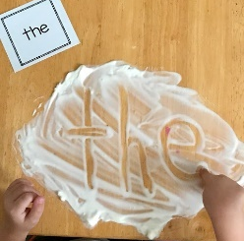  Spray some shaving cream onto the table and use your finger to write your sight words in it | 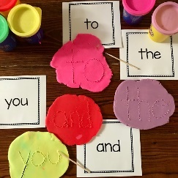  Flatten a piece of play doh and use a toothpick or skewer to write sight words in the playdoh | 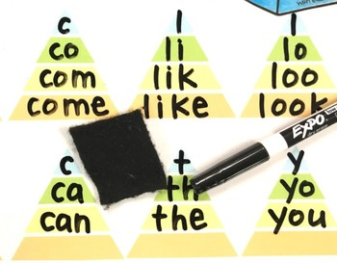  Sight word pyramids | Paint your sight words on concrete using water and a paint brush  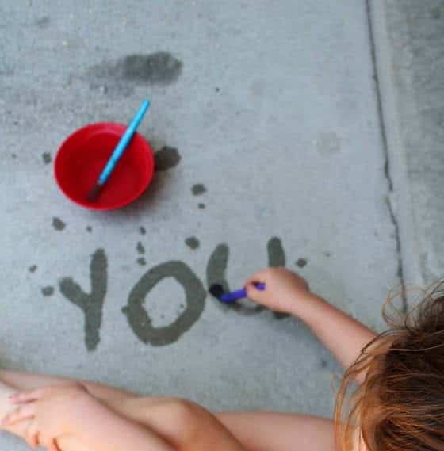 | 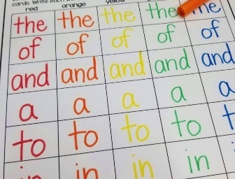  Write your sight words in rainbow colours

